Original Article / Artykuł oryginalny

Title
Firstname Lastname ¹, Firstname Lastname ², Firstname Lastname ³*
1. Affiliation 1 ([Department / Unit], [Faculty], [University / Institution], [Street name + number], [Postal code + City], [Country] (Example:
Department of Cosmetology, Faculty of Health Sciences, Medical University of City X, Great Street 61, XX-XXX City name, Country name; For authors affiliated with private clinics, companies, or laboratories, please provide the full address in the same format)
2. Affiliation 2
*Corresponding author: Name Surname, e-mail@e-mail.com; (one corresponding author is allowed)

ORCID numbers of the authors: Name Surname ORCID number; Name Surname2 ORCID number2
Abstract
The abstract should consist of a single paragraph of up to 250 words. It should accurately reflect the content of the manuscript and may not contain statements, results, or conclusions that do not appear in the main text. For original research articles, the abstract should provide a concise and relevant overview of the study. Authors are encouraged to use a structured approach, following the elements listed below:
Introduction: briefly present the scientific context and the problem addressed in the study;
Aim: clearly state the purpose of the research;
Materials and methods: outline the primary methods, procedures, or analyses applied;
Results: summarize the key findings of the study;
Conclusions: indicate the main interpretations, implications, or practical relevance.
Keywords: keyword 1, keyword 2, keyword 3, keyword 4, keyword 5. (List five to six keywords specific to the article)

Introduction
The introduction should clearly present the scientific context of the work, outline the current state of knowledge, and indicate the relevance of the problem addressed in the manuscript. It should explain why the topic is important for the field of aesthetic cosmetology, dermatology, or related disciplines, and briefly summarize the most significant findings from recent literature [1]. The introduction must logically lead to the aim of the study, identifying the knowledge gap, methodological limitations, or unresolved issues that justify undertaking the research. Authors should avoid providing detailed results, methodological descriptions, or extensive literature reviews in this section. The introduction should be concise, well structured, and directly related to the main objective of the manuscript [1-3].

AIM
Briefly describe aim of the study.

Materials and Methods
The Materials and Methods section should provide a clear, detailed, and reproducible description of all procedures, materials, equipment, and analytical methods used in the study. Authors should specify the study design, characteristics of the study population or sample, inclusion and exclusion criteria (if applicable), and the ethical approval number for research involving humans or animals.
Materials
All materials, instruments, and software should be identified by name, manufacturer, city, and country. This is where a description of the study group (people included in the experiment) should be included, if such a group is present in the study.
Method 1
The methods must be described with sufficient precision to allow other researchers to replicate the study.
Method 2
Statistical procedures should include the names of applied tests, significance thresholds, and software used for analyses.
Additional subsection to method 2
Any previously published methods should be cited appropriately and only briefly summarized. The section should not contain results or interpretation of results. The equation should be presented as follows:
“…was calculated using the following equation (1)[2]:
$A=\frac{B}{C}x100\%.$ (1)
Equations should not be numbered as figures but should have their own numbering (as in the example: (1)). Please remember to include a citation to the source.

Results
The Results section should present the findings of the study clearly, objectively, and without interpretation.
Results section 1
Data must be organized in a logical sequence, following the structure of the applied methods. Authors should use tables, figures, and charts when appropriate, ensuring that all graphical elements are referenced in the text and numbered consecutively. When a figure is mentioned within a sentence, write fig. 1 in lowercase (e.g., “as shown in fig. 1”). In parentheses, use the abbreviated form with a capital letter: (Fig. 1). Do not use bold or italics when citing figures or tables in the text.
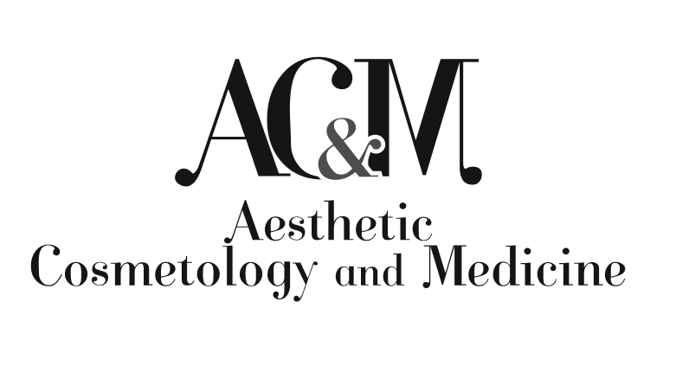
Fig. 1. Title of the figure/graphical object. Please provide a detailed description of the figure content. Source: (Please provide source of the graphical object, for example: [1] / own elaboration / own archive).

Results subsection 1
The same rules apply to the description and citation of tables (Tab. 1).

Tab. 1. Table title. Source: (Please provide source of the graphical object, for example: [1] / own elaboration / own archive).
 | X | X | X
Y
Y

Only the most relevant results should be highlighted in the text, while detailed datasets may be included in supplementary materials if necessary.

Results section 2
Statistical outcomes should include exact values, confidence intervals, and significance levels. The section should not contain discussion, literature references, or explanations of the findings – these belong in the Discussion section. Results should be presented in a concise and transparent manner to allow readers to easily understand the main outcomes of the research.

DISCUSSION
The Discussion section should interpret and explain the results of the study in the context of current scientific knowledge. Authors should compare their findings with previously published research and highlight both consistencies and discrepancies. The interpretation must be supported by relevant literature, cited in numerical order according to appearance (e.g. [1] or [2, 3-6]). The discussion should explain the significance of the results, their potential practical implications, and the contribution of the study to the field of aesthetic cosmetology or related disciplines.
Authors are encouraged to critically evaluate the strengths and limitations of their study. For example, findings may align with earlier reports on similar interventions [5], yet differ from more recent analyses focusing on alternative methodologies [6, 7]. Any unexpected outcomes should be discussed with reference to available evidence and potential methodological constraints [8].
The section should remain focused, coherent, and avoid repeating data already presented in the Results. Speculative statements must be clearly identified as such. The discussion should lead naturally to the conclusions drawn from the study.

Conclusions
The Conclusions should clearly state the main outcomes of the study and their significance for research or practice. Conclusions must be directly supported by the results presented in the manuscript and should not introduce new data or interpretations.

SUMMARY
The Summary should briefly outline the aim of the study, the methodology used, and the key findings. It should provide a concise overview of the manuscript without detailed interpretation or the introduction of new information.

Conflicts of Interest
All authors must disclose any financial or personal relationships that could influence the work. If no conflicts exist, please state: “The authors declare no conflicts of interest.”

Funding
Authors should indicate all sources of financial support or state: “This research received no external funding.”

Authors’ Contributions
Please specify the contribution of each author using the CRediT taxonomy (e.g. Conceptualization, Methodology, Writing – Original Draft, Supervision, etc.) and authors’ initials.

Ethics statement
Please include the statements applicable to your study.
Research involving human participants
“The study was conducted in accordance with the Declaration of Helsinki and approved by [full name of ethics committee/IRB] (approval number: XXX, approval date: XXX).”
“Informed consent was obtained from all subjects involved in the study.”
“Written informed consent for publication of identifiable data/images was obtained from the participant(s) where applicable.”
“Ethical approval was not required for this study because [provide reason].”
Research involving animals
“All procedures involving animals were conducted in accordance with institutional and ethical guidelines and approved by [name of ethics committee/authority] (approval number: XXX).”
Research involving cell lines or biological material
“Information about the source of cell lines or biological material used in the study is provided in the Materials and Methods section.”
“All procedures were conducted in accordance with relevant institutional and ethical regulations.”
If the study did not involve human participants, animals, cell lines, or biological material, please state:
“Not applicable.”

Use of AI Tools
Authors must disclose any use of artificial intelligence tools in writing, editing, data analysis, or image generation. AI tools cannot be listed as authors.

references / LITERATURA
The References section should include only the sources cited in the manuscript. All references must be formatted according to the AMA (American Medical Association) citation style and listed in the order of their appearance in the text. Citations in the manuscript should be indicated using Arabic numerals in square brackets, placed before the period (e.g. [1], [2, 3], [4-6]). Authors may prepare references manually or use automated citation tools (e.g., EndNote, Zotero, Mendeley, or the built-in citation managers available in most text editors). Regardless of the method used, authors are fully responsible for the accuracy and completeness of all bibliographic details. Only works that have been published or officially accepted for publication may appear in the reference list.
Please note that manuscripts with incorrectly formatted references will be returned to the authors for correction before entering the review process. Ensuring correct formatting significantly speeds up editorial handling and peer review [1].
1. Name X, Name Y. Article title. Journal name. 2025;X(Y): X-XX. https://doi.org/ doi.number/ofthecitedarticle
Examples of reference formatting (AMA style)

Journal articles
1. Armatys B, Kita A, Kurkiewicz-Piotrowska A. Peppermint essential oil in cosmetology and aromatherapy. Aesth Cosmetol Med. 2025;14(6):275-282. https://doi.org/10.52336/acm.2025.040.
2. Utomo T, Widita W, Anwar AI. Anti-aging properties of the probiotic strain Lactobacillus plantarum ATCC 8014. Preliminary report. Aesth Cosmetol Med. 2025;14(2):79-83. https://doi.org/10.52336/acm.2025.012.

Books (single or multiple authors)
3. Guy RH, Hadgraft J. Transdermal Drug Delivery. 2nd ed. New York: M. Dekker; 2003.
4. Marks R, Miller J. Principles of Dermatology. 4th ed. London: Elsevier; 2015.

Edited books (collective works)
5. Orfanos CE, Happle R, eds. Hair and Hair Diseases. Berlin: Springer-Verlag; 1990.
6. Chen K, Wright P, eds. Advances in Cosmetic Science. Oxford: Oxford University Press; 2019.

Chapter in a book
7. Cesarini JP. Hair melanin and color. In: Orfanos CE, Happle R, eds. Hair and Hair Diseases. Berlin: Springer-Verlag; 1990:165–197.
8. Patel S. Anti-aging peptides: mechanisms and clinical relevance. In: Chen K, Wright P, eds. Advances in Cosmetic Science. Oxford: Oxford University Press; 2019:55–88.

Internet sources
9. World Health Organization. Ageing and health. World Health Organization. Published October 1, 2025. Accessed January 21, 2026. https://www.who.int/news-room/fact-sheets/detail/ageing-and-health

